Web I like

<http://zoomquilt.org/>

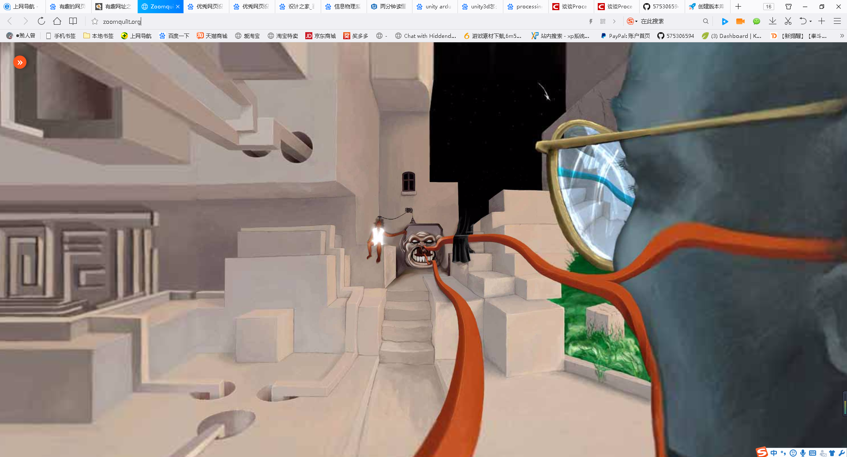

It's a fairy tale website.The animation consists of an infinite loop.Give the viewer a different artistic experience.

<http://strml.net/>

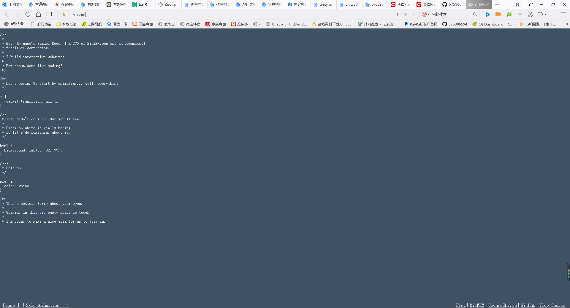

This programmer, uses codes to introduce himself, and what is his job, and shows us some easy codes.

<https://2050.earth/#>

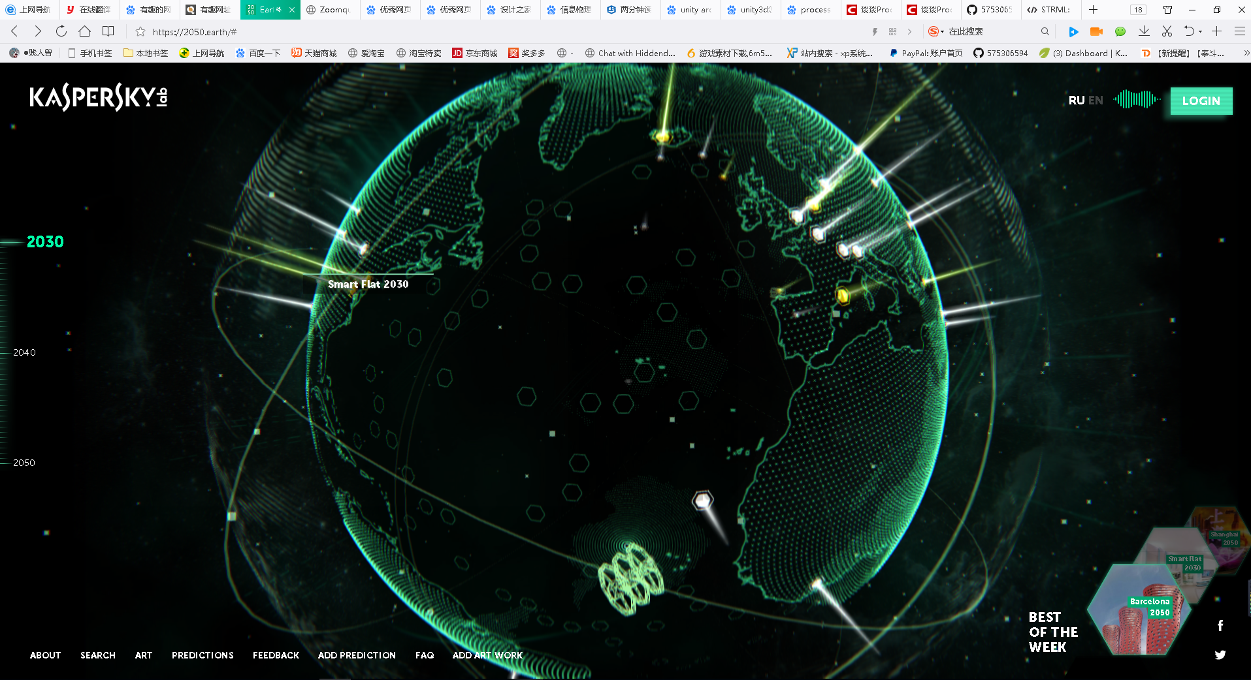

It shows us the world cities of 2030, 2040 and 2050. 360 - degree panoramic.

Web I dislike

<http://app.tanwan.com/htmlcode/19054.html>

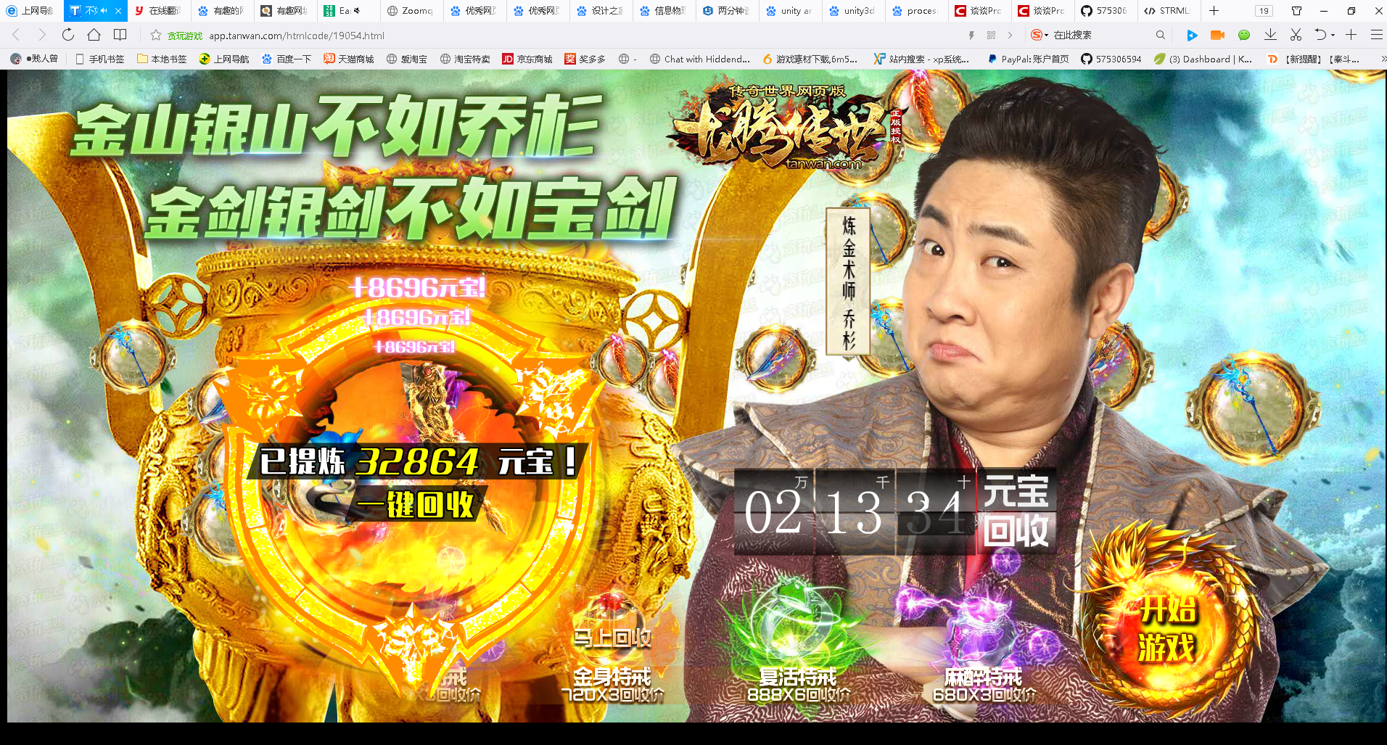

This is a game, but this game no art no emotional appeal, just money, money and money.

<https://daohang.qq.com/?unc=Af31009>

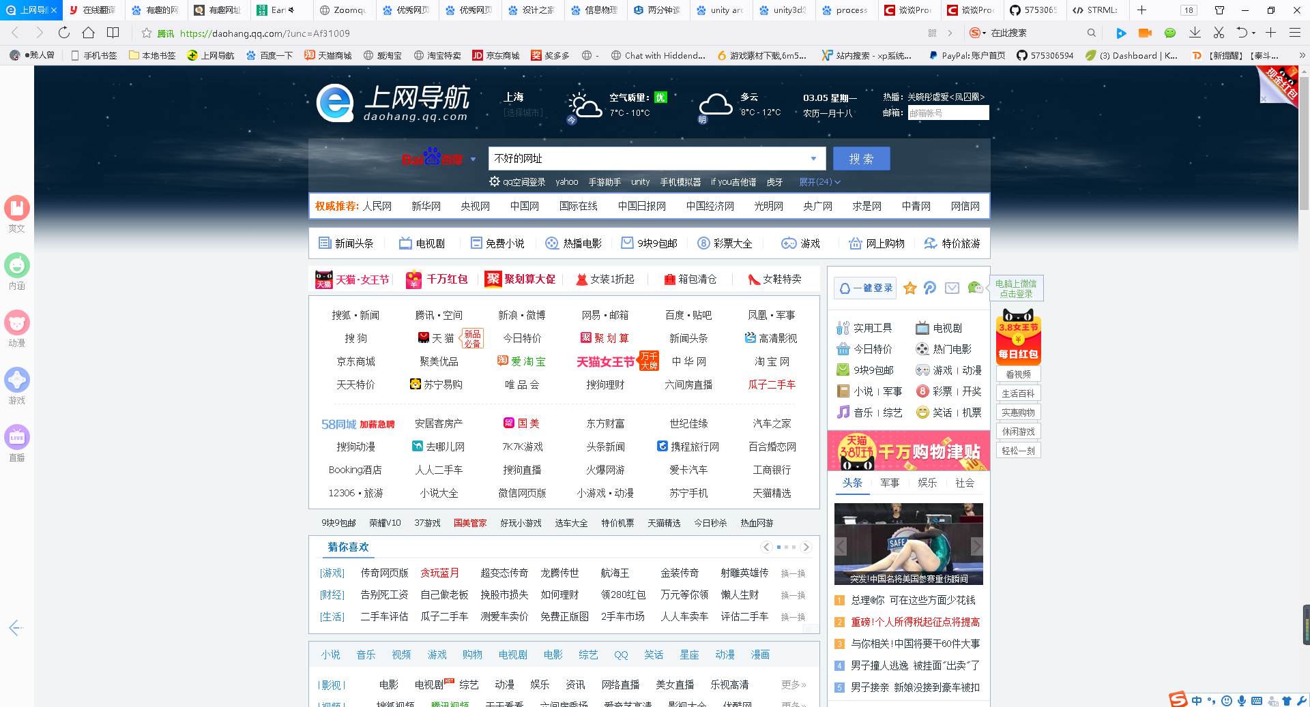

Although this web is very useful, but this design has no typography, just a list about other web.